Adding a Driver to GeoTab (Not needing GeoTab Access)
- In GeoTab go to Administration and select Users.
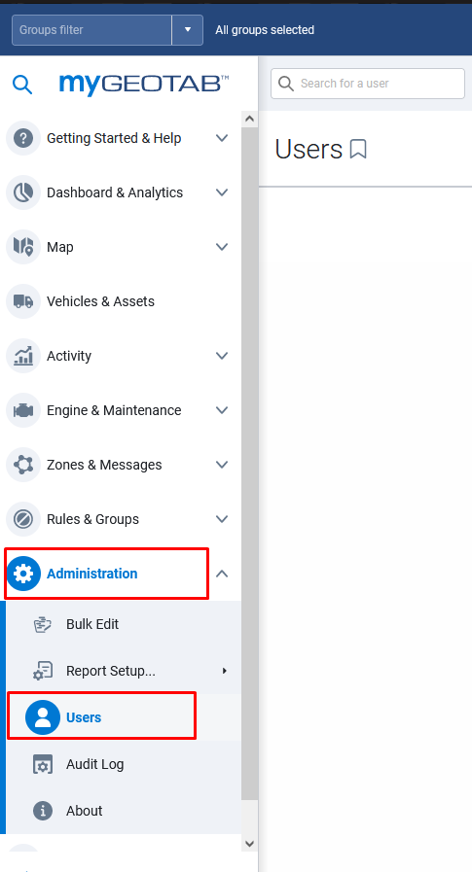
- When you get to the user list select Add towards the top middle of the screen.
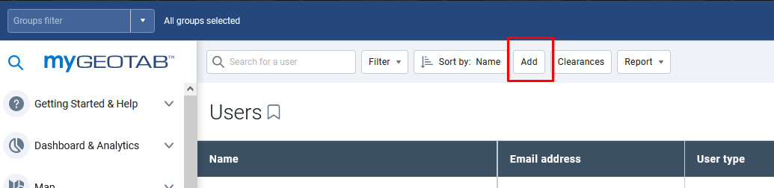

- The Add User page will open. Fill in the Driver’s email, first name, and last name. Change “Force password change on next login” to No and type in a generic password for the driver. Under “Groups:” select the appropriate Bill Code for the driver.
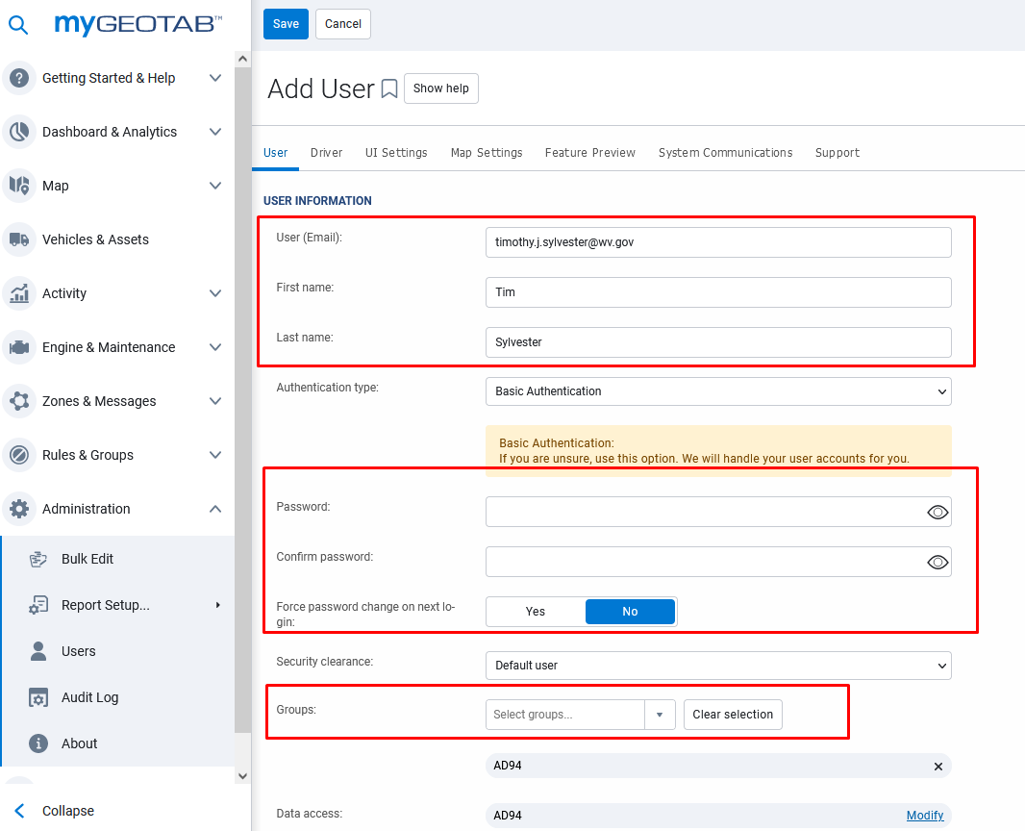

- Select the Driver tab under Add User. Select Yes for “This user is a driver:”. Make sure that Yes is selected for “Prevent driver access to shared data:”. Click “Add new driver key” and in the dropdown, select NFC. In the box below NFC type in the number that appears on the key FOB you are assigning the driver and click the check mark box. Click save at the top left of the screen and that driver will now be able to FOB into vehicles with Telematics.
