Adding a User to GeoTab (Giving a user access to see vehicles in GeoTab)
- In GeoTab go to Administration and select Users.
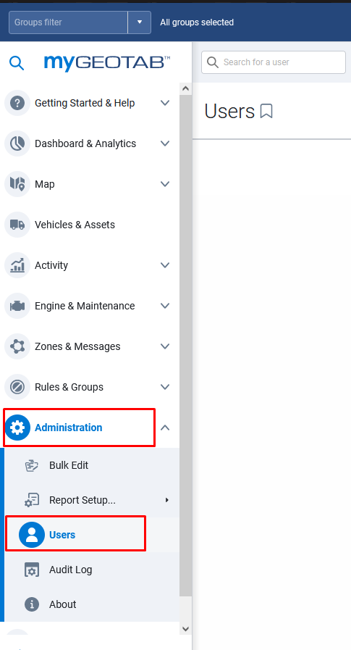
- When you get to the user list select Add towards the top middle of the screen.
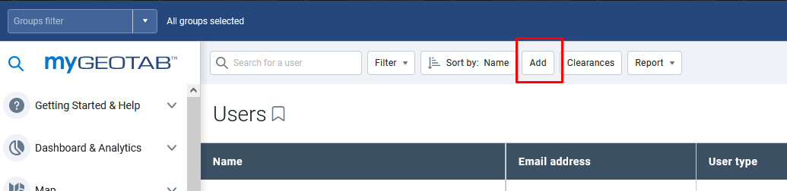

- The Add User page will open. Fill in the User’s email, first name, and last name. Keep “Force password change on next login” on Yes. Under the Security Clearance dropdown box select “Admin – State of West Virginia”. Under the Groups: dropdown box select the appropriate Bill Code(s) for the user. Under the “Additionally allow reporting by these groups:” select Reporting and then All In Reporting. Click Save at the top of the screen. An email will be sent to the user prompting them to log in and confirm their GeoTab account.
